List
Tele-Words
A list is used for storing data, just like a variable. However, a variable can store only one piece of data at a time in a named location, a list can store many.
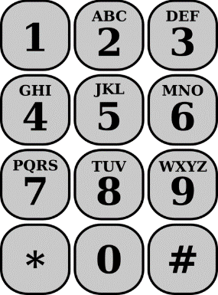
Get Ready
- Get project: Click on “Code” and then click save
Add Your Code
- In the main block, add variables
char teleWord[10], ch;
int length;
- Ask player to enter 10 alphabets
printf("Enter 10 letters (e.g. 'DIALaPIZZA') : ");
scanf("%[^\n]s", teleWord);
- Check the length of teleWord. If it is less than 10, print message “Wrong length” and quit program
length = strlen(teleWord);
if (length != 10){
printf("Wrong length\n");
return (0);
}
Try It Out!
- Click on Save. Click on Run.
- What is the number for 1800-track?
- Remember! return 0 is used at the end of main block to indicate program has completed successfully.
Challenge!
Add heading
Print heading 'Telephone keypad' at the start of the program
Word length
Accept 12 letters instead of 10
Letter Z
For letter 'z' print number 0
Name – New Project
Ask player for their name. Print 3rd letter of the name.
Test Yourself!
What will the program print?
char hobby[20];
printf("Your hobby: ");
scanf("%s",&hobby);
printf("%s",hobby[0]);
Fun Fact
The 'f' in printf and scanf stands for "formatted"

